Test Case: tc002_SPX_Dev5_Crear_Requisicion_Spot_Con_FAD_Tipo_Cobro_CC
Step 1 - Enter username and password and click to button Enter : Credentials Entered
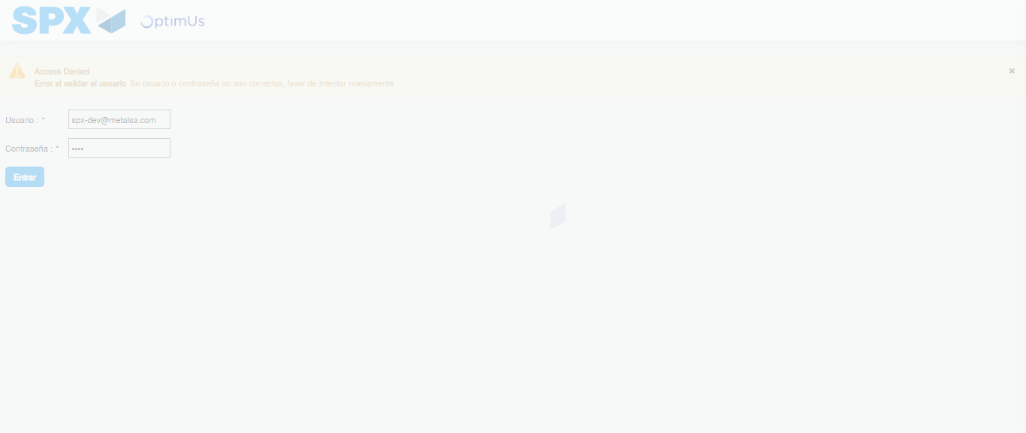Image file-name: QC_Testing-tc002_SPX_Dev5_Crear_Requisicion_Spot_Con_FAD_Tipo_Cobro_CC-1790179218545

Step 2 - Select to UEN and Access to Spot Buy Requisitions : UEN Correctly selected and Correct access
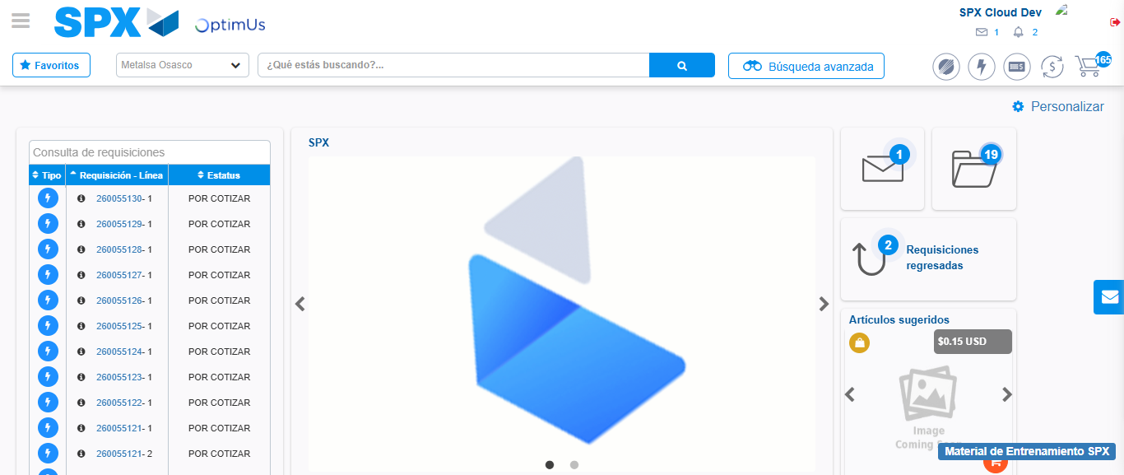Image file-name: QC_Testing-tc002_SPX_Dev5_Crear_Requisicion_Spot_Con_FAD_Tipo_Cobro_CC-1790179242803

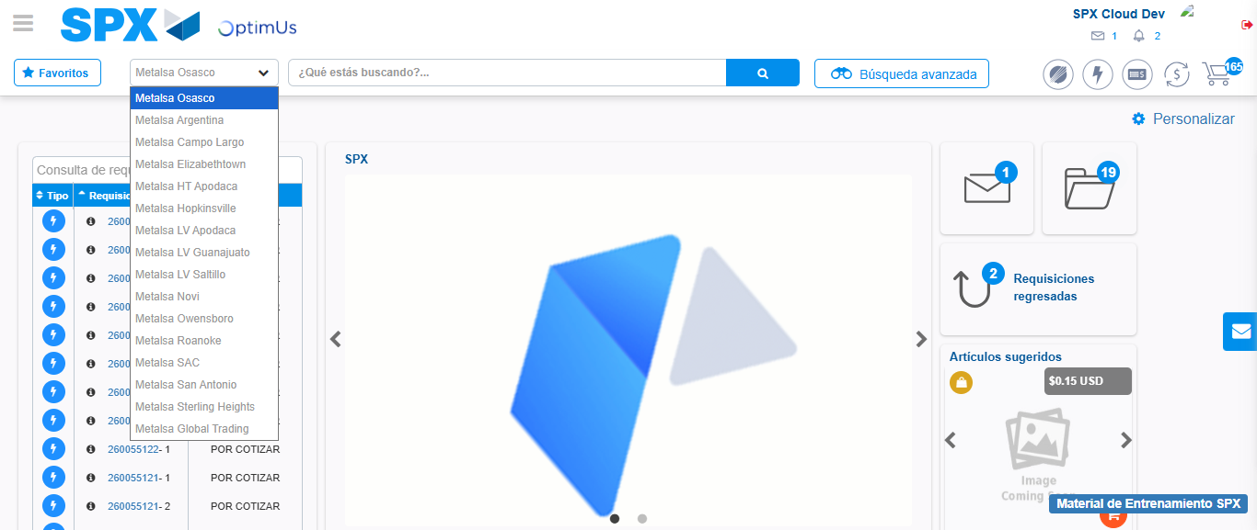Image file-name: QC_Testing-tc002_SPX_Dev5_Crear_Requisicion_Spot_Con_FAD_Tipo_Cobro_CC-1790179243283

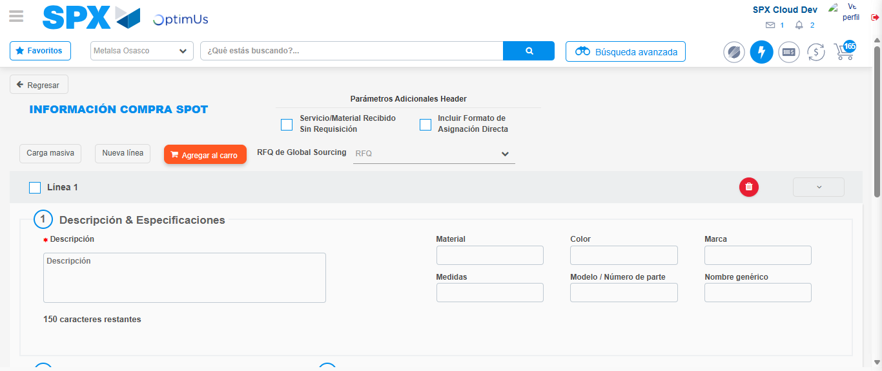Image file-name: QC_Testing-tc002_SPX_Dev5_Crear_Requisicion_Spot_Con_FAD_Tipo_Cobro_CC-1790179248446

Step 3 - Add FAD to Requisition: FAD Successfully Added
Image file-name: QC_Testing-tc002_SPX_Dev5_Crear_Requisicion_Spot_Con_FAD_Tipo_Cobro_CC-1790179248684

Image file-name: QC_Testing-tc002_SPX_Dev5_Crear_Requisicion_Spot_Con_FAD_Tipo_Cobro_CC-1790179248877

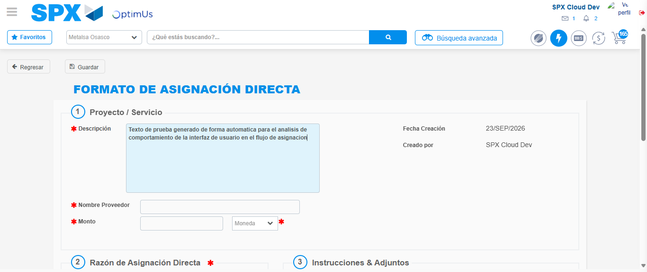Image file-name: QC_Testing-tc002_SPX_Dev5_Crear_Requisicion_Spot_Con_FAD_Tipo_Cobro_CC-1790179251546

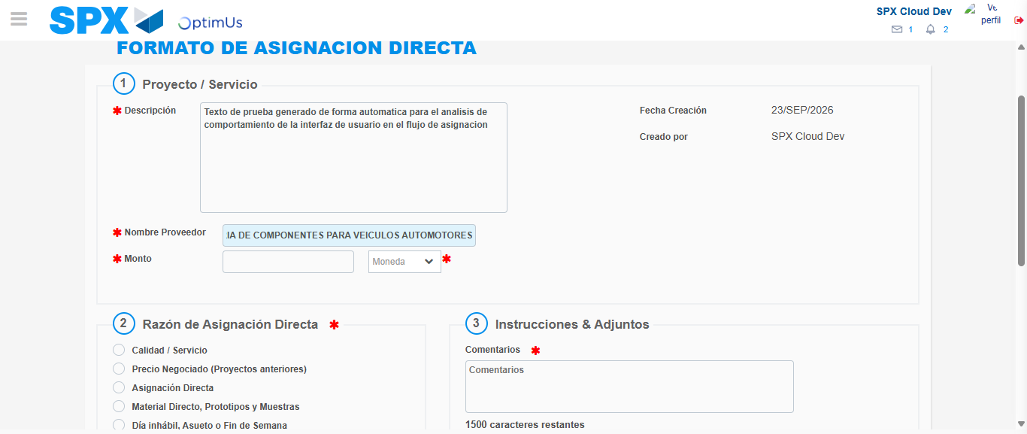Image file-name: QC_Testing-tc002_SPX_Dev5_Crear_Requisicion_Spot_Con_FAD_Tipo_Cobro_CC-1790179259842

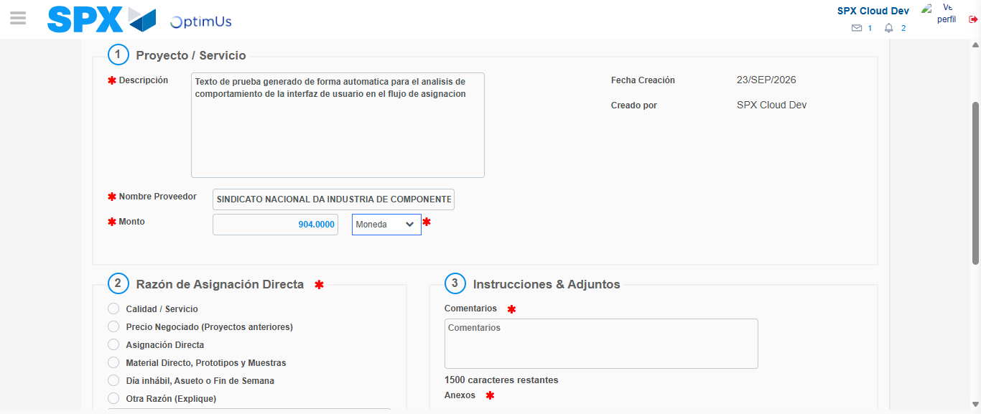Image file-name: QC_Testing-tc002_SPX_Dev5_Crear_Requisicion_Spot_Con_FAD_Tipo_Cobro_CC-1790179260178

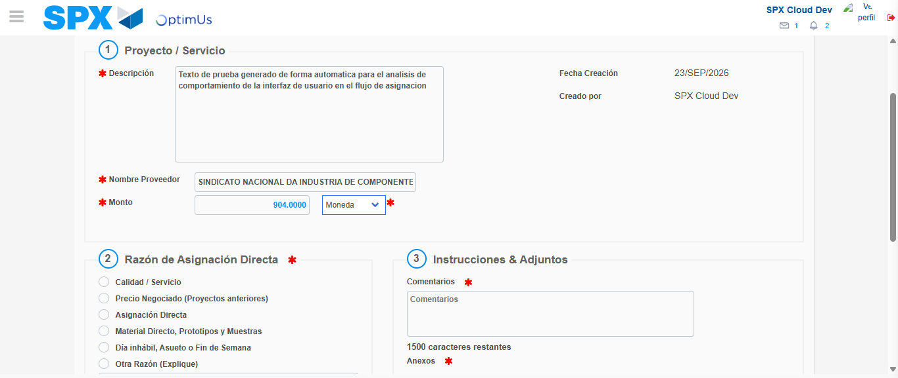Image file-name: QC_Testing-tc002_SPX_Dev5_Crear_Requisicion_Spot_Con_FAD_Tipo_Cobro_CC-1790179260352

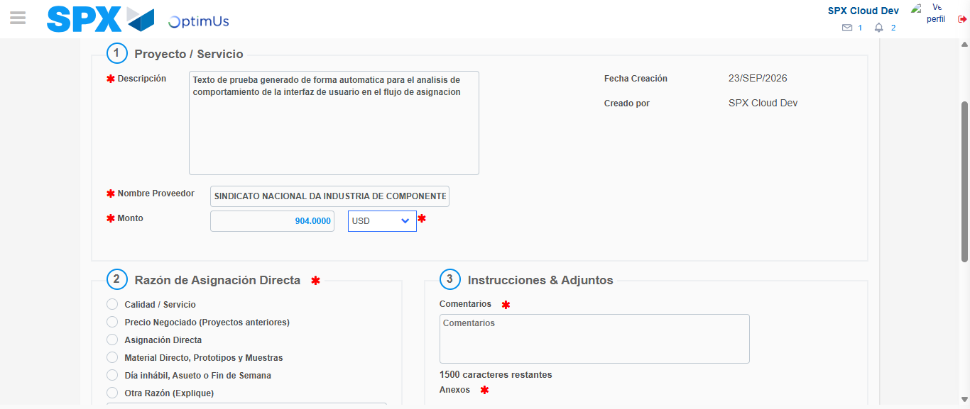Image file-name: QC_Testing-tc002_SPX_Dev5_Crear_Requisicion_Spot_Con_FAD_Tipo_Cobro_CC-1790179260652

Image file-name: QC_Testing-tc002_SPX_Dev5_Crear_Requisicion_Spot_Con_FAD_Tipo_Cobro_CC-1790179260829

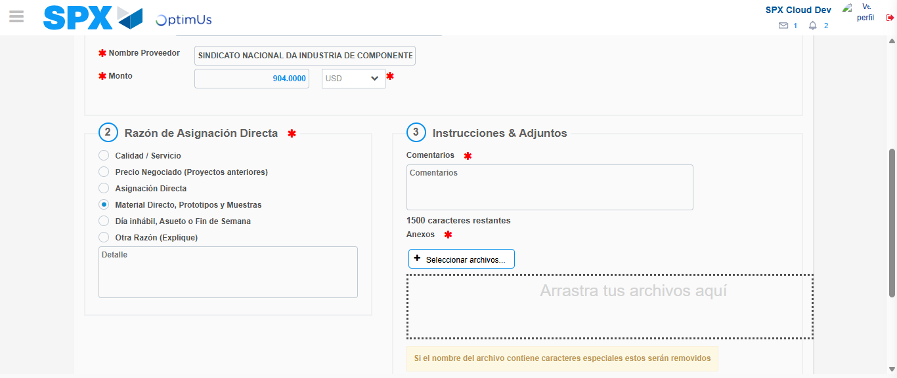Image file-name: QC_Testing-tc002_SPX_Dev5_Crear_Requisicion_Spot_Con_FAD_Tipo_Cobro_CC-1790179261597

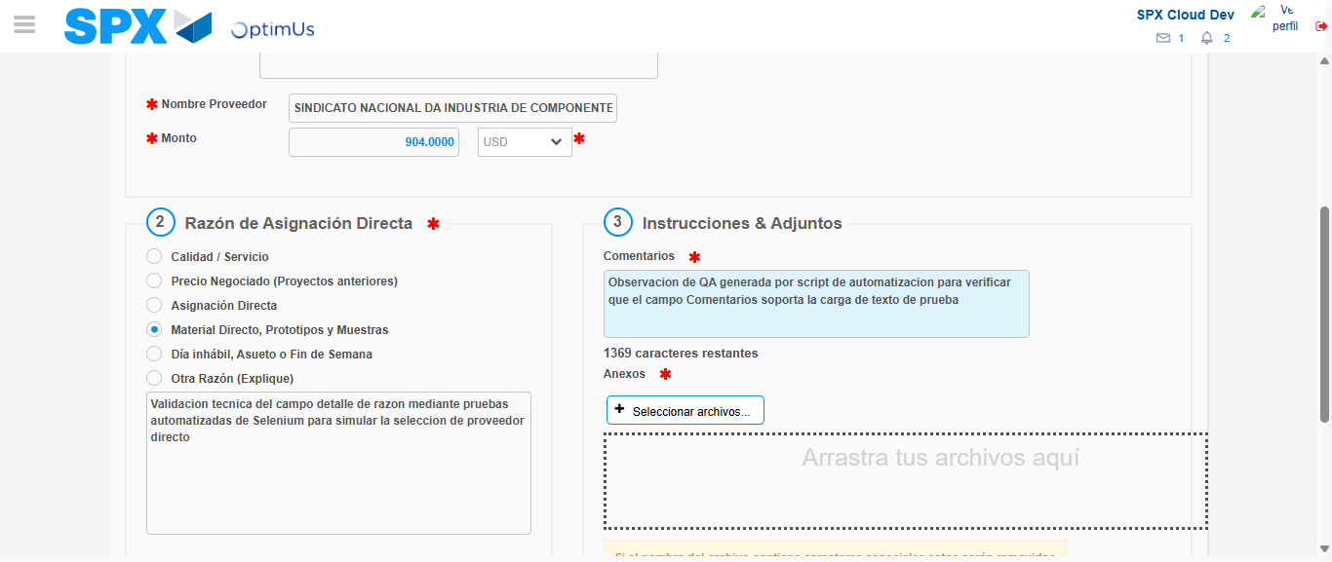Image file-name: QC_Testing-tc002_SPX_Dev5_Crear_Requisicion_Spot_Con_FAD_Tipo_Cobro_CC-1790179272530

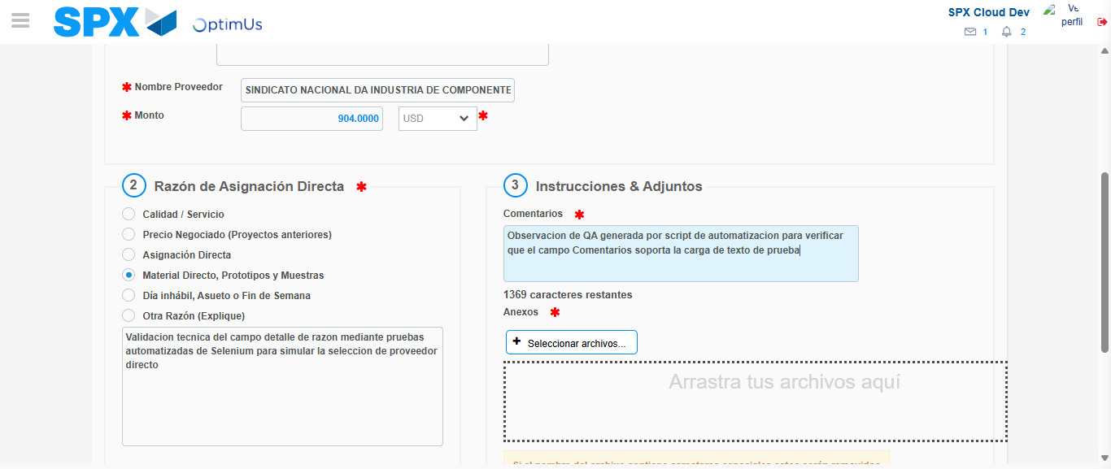Image file-name: QC_Testing-tc002_SPX_Dev5_Crear_Requisicion_Spot_Con_FAD_Tipo_Cobro_CC-1790179273135

Step 4 - Data Capture Spot Buy Requisition: Data captured correctly
Image file-name: QC_Testing-tc002_SPX_Dev5_Crear_Requisicion_Spot_Con_FAD_Tipo_Cobro_CC-1790179248684

Image file-name: QC_Testing-tc002_SPX_Dev5_Crear_Requisicion_Spot_Con_FAD_Tipo_Cobro_CC-1790179248877

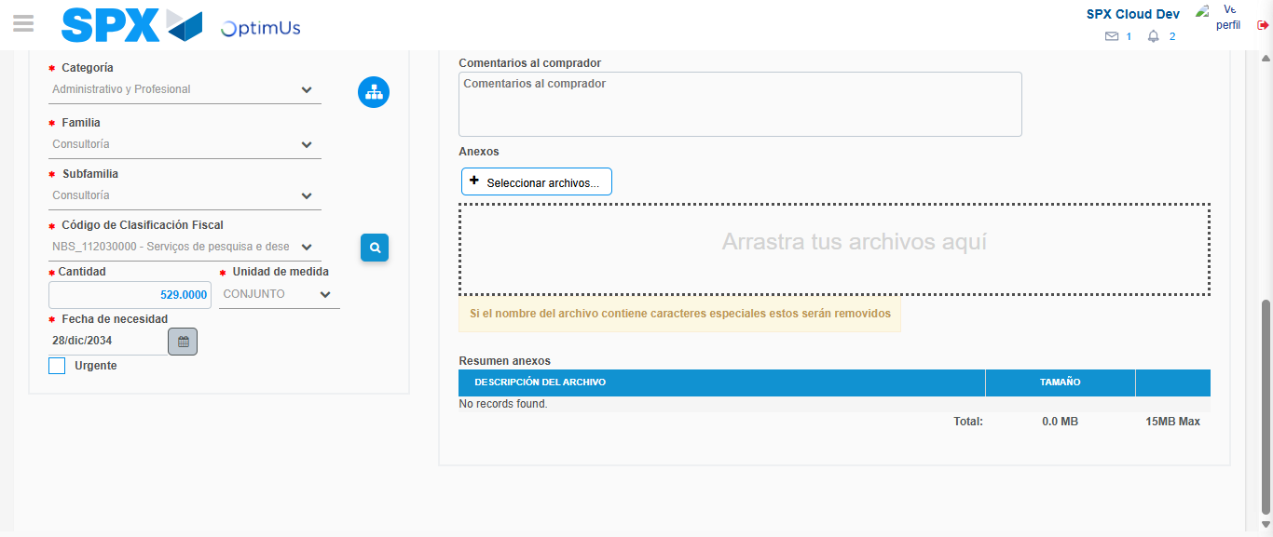Image file-name: QC_Testing-tc002_SPX_Dev5_Crear_Requisicion_Spot_Con_FAD_Tipo_Cobro_CC-1790179291863

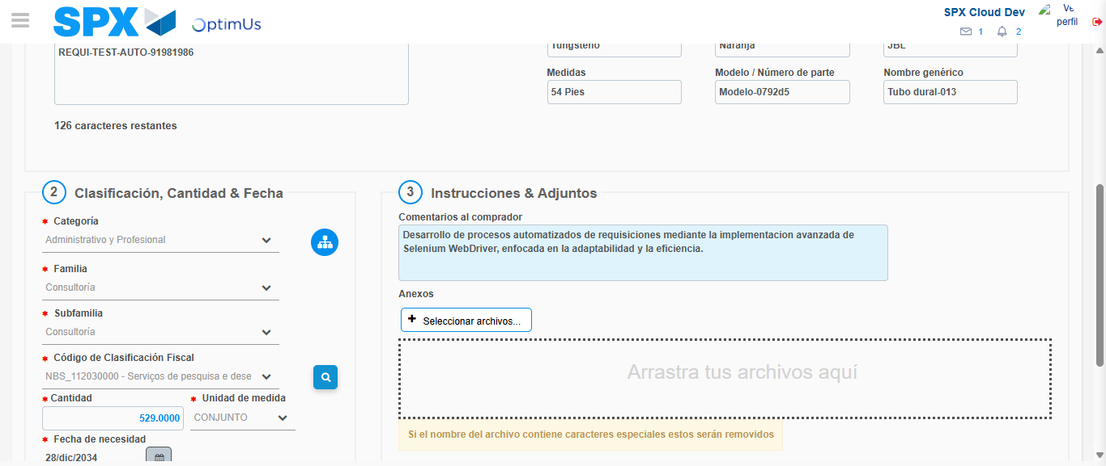Image file-name: QC_Testing-tc002_SPX_Dev5_Crear_Requisicion_Spot_Con_FAD_Tipo_Cobro_CC-1790179302592

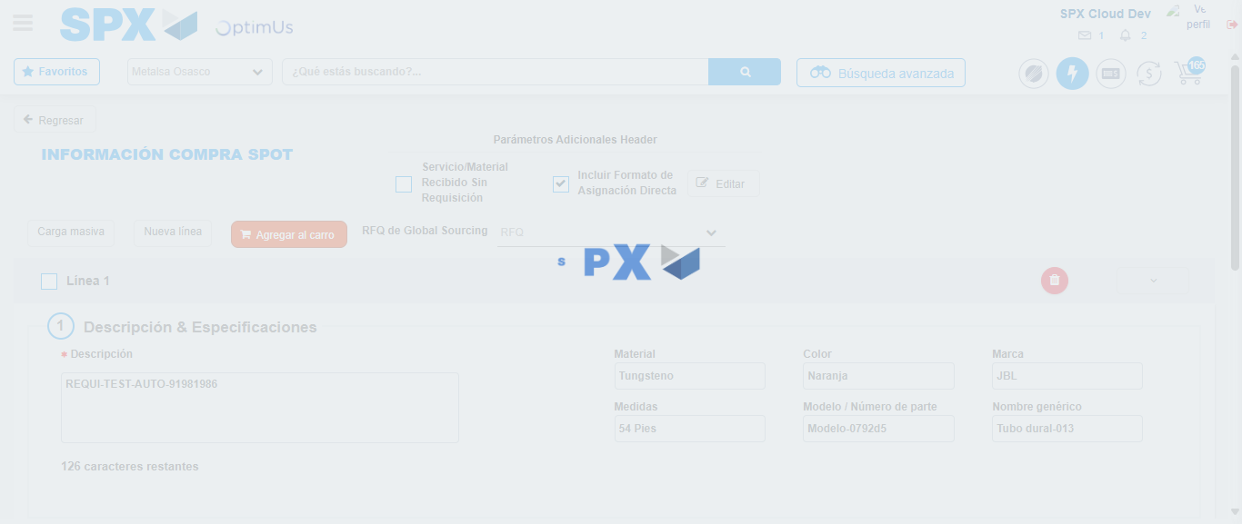Image file-name: QC_Testing-tc002_SPX_Dev5_Crear_Requisicion_Spot_Con_FAD_Tipo_Cobro_CC-1790179323091

Step 8 - Return to Main Page SPX : Return to Main Page SPX
Image file-name: QC_Testing-tc002_SPX_Dev5_Crear_Requisicion_Spot_Con_FAD_Tipo_Cobro_CC-1790179242803

Image file-name: QC_Testing-tc002_SPX_Dev5_Crear_Requisicion_Spot_Con_FAD_Tipo_Cobro_CC-1790179243283

Image file-name: QC_Testing-tc002_SPX_Dev5_Crear_Requisicion_Spot_Con_FAD_Tipo_Cobro_CC-1790179248446

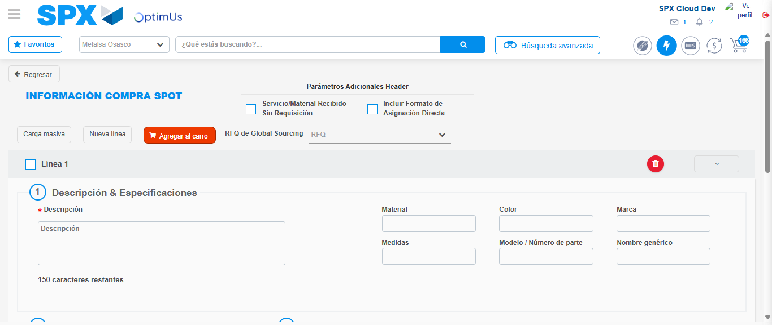Image file-name: QC_Testing-tc002_SPX_Dev5_Crear_Requisicion_Spot_Con_FAD_Tipo_Cobro_CC-1790179325306

Image file-name: QC_Testing-tc002_SPX_Dev5_Crear_Requisicion_Spot_Con_FAD_Tipo_Cobro_CC-1790179325483

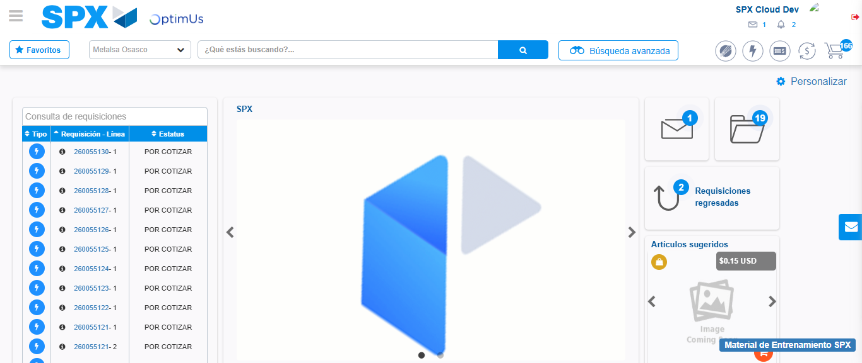Image file-name: QC_Testing-tc002_SPX_Dev5_Crear_Requisicion_Spot_Con_FAD_Tipo_Cobro_CC-1790179346585

Step 9 - Log Out : Log Out SPX
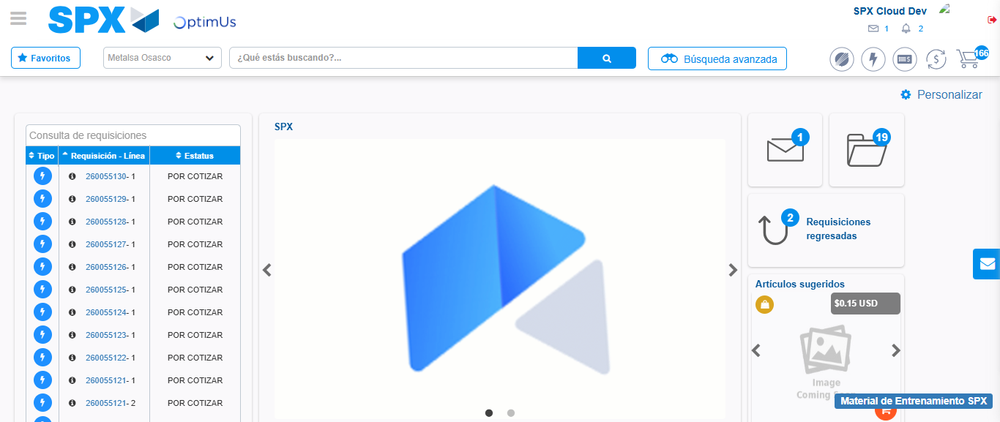Image file-name: QC_Testing-tc002_SPX_Dev5_Crear_Requisicion_Spot_Con_FAD_Tipo_Cobro_CC-1790179346876

